Intentional bugs  
ACME-GALLERY 1.0

|  |  |
| --- | --- |
| ****Development team**** | |
| **Identifier** | G89 |
| **Members** | Bellido Cuesta, José Manuel; Carmona Fombella, José Antonio; Viñas Ordóñez, Alicia. |
| **Testing team** | |
| **Identifier** | G21 |
| **Members** | Caraballo de la Rosa, Miguel; Izaga Ramírez, Ángel; Luna Rodríguez, Nicolás; Morato Fernández, Natalia; Ranedo Rubio, Francisco José. |
| **Indexing data** | |
| **Designers** | Bellido Cuesta, José Manuel; Carmona Fombella, José Antonio, Viñas Ordóñez, Alicia |
| **Testers** | Caraballo de la Rosa, Miguel; Izaga Ramírez, Ángel; Luna Rodríguez, Nicolás; Morato Fernández, Natalia; Ranedo Rubio, Francisco José. |
| **Notes** |  |

|  |
| --- |
| ****Effectiveness**** |
| 7 intentional bugs found from a total number of 10 intentional bugs: 70% found. |

Table of contents

Bug in use case 002 – Search Exhibitions 3

Bug in use case 003 – Register as a Sponsor 5

Bug in use case 021 – Director edit an Exhibition 7

Bug in use case 024 – Director check an Incident 9

Bug in use case 025 – Director delete an Incident 11

Bug in use case 026 – Director create a Museum 13

Bug in use case 030 – Director create a Room 15

Bug in use case 032 – Director mark a Room in repair 17

Bug in use case 042 – Visitor create a Comment 19

Bug in use case 043 – Visitor buy a day pass for an exhibition 20

# Bug in use case 002 – Search Exhibitions

Description

When displaying an Exhibition, we changed the price pattern so that it is the same (“€X.XX”) in English and in Spanish. In our acceptance tests, we asked to check that the price pattern is “€X.XX” in English and “X,XX€” in Spanish.

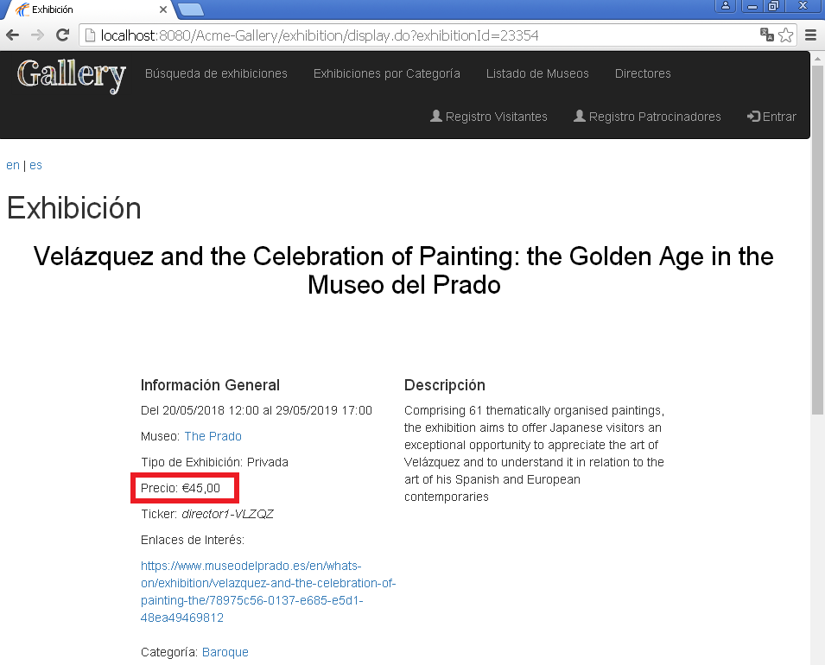Screenshot of the expected wrong results:

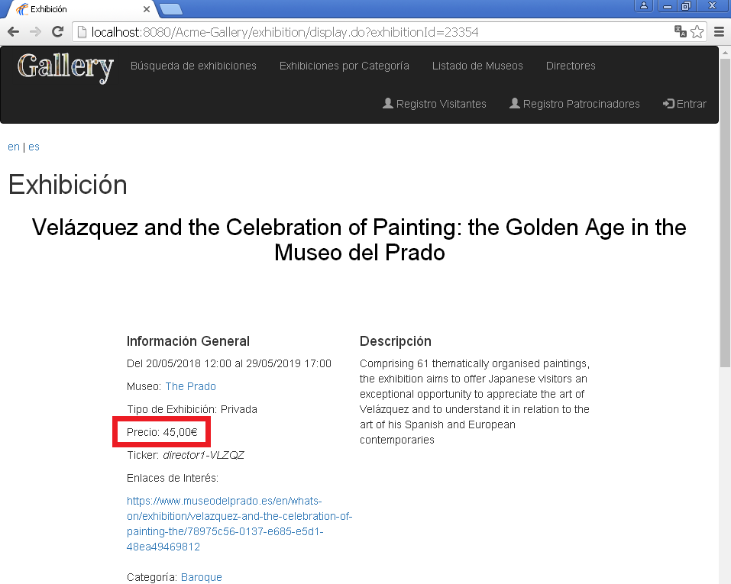Screenshot of the correct results:

Results

We made it explicit on Test #008 from UC002 to check that the pattern was X,XX€ (es) and €X.XX (en).

The testers didn’t report on this error and wrote down it worked as expected.

# Bug in use case 003 – Register as a Sponsor

Description

We removed the @SafeHtml annotation from the username and password of UserAccount so that XSS could be carried out on that properties. Thus, no error message is shown when you try it

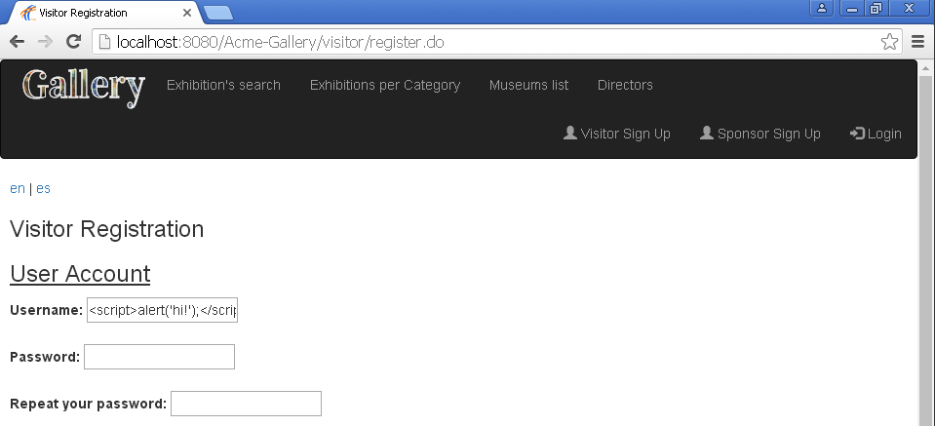Screenshot of the expected wrong results:

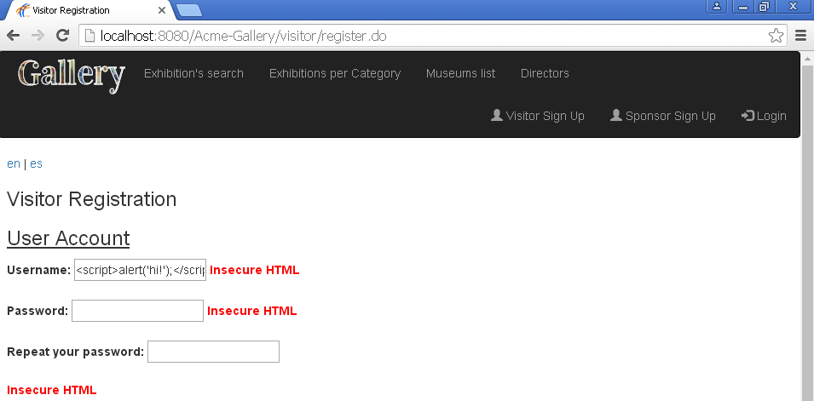Screenshot of the correct results:

Results

We made it explicit on Test #004 from UC003 to try XSS in the registration of a Sponsor by entering “<script>alert(‘hacked!’);</script>” in all of its properties and check that the “Insecure HTML” error is shown in all of them.

The testers reported on this error and wrote down the “Insecure HTML” error message was only shown in the fields: *name*, *surname* and *address*.

# Bug in use case 021 – Director edit an Exhibition

Description

When editing an exhibition, we wrote the message of your current exhibitions in English and didn’t internationalize it for the Spanish view.

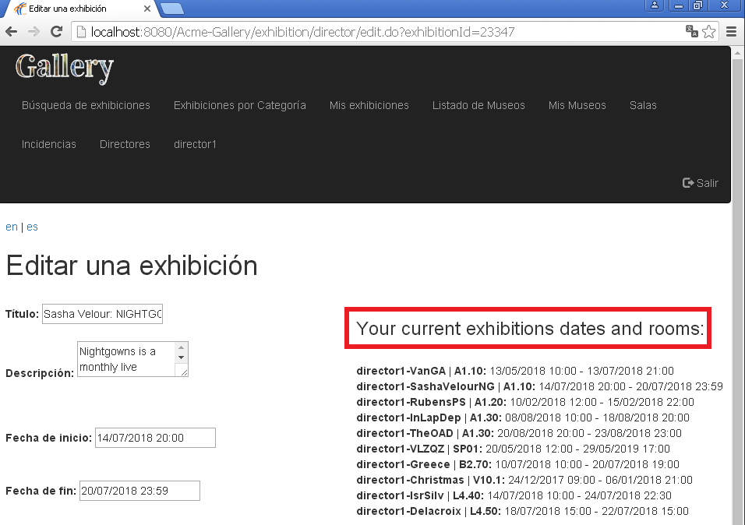Screenshot of the expected wrong results:

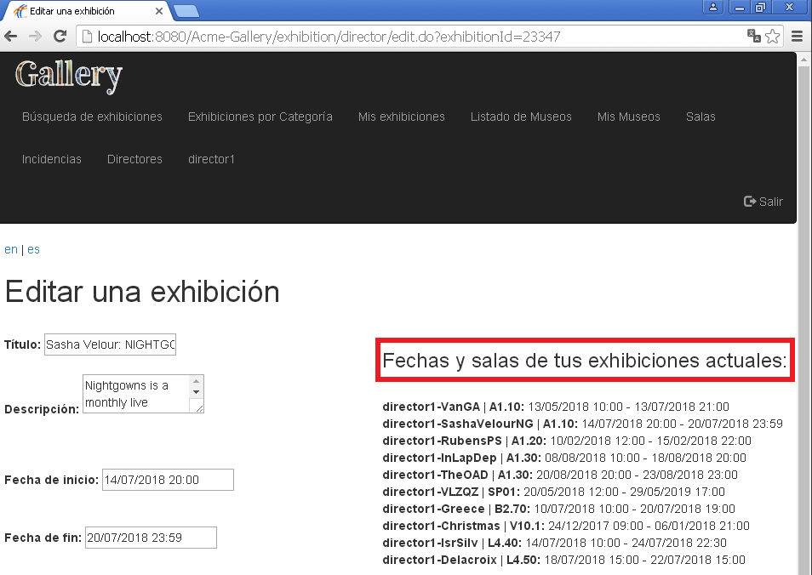Screenshot of the correct results:

Results

We made it explicit on Test #018 from UC021 to try the UC in Spanish and check that all the messages were written in Spanish.

The testers didn’t report on this error and wrote down they didn’t know the credentials to log in as a Director.

# Bug in use case 024 – Director check an Incident

Description

We removed the sortable attribute from the severity level column in the Incidents’ listings but, included that functionality in the acceptance tests as mandatory.

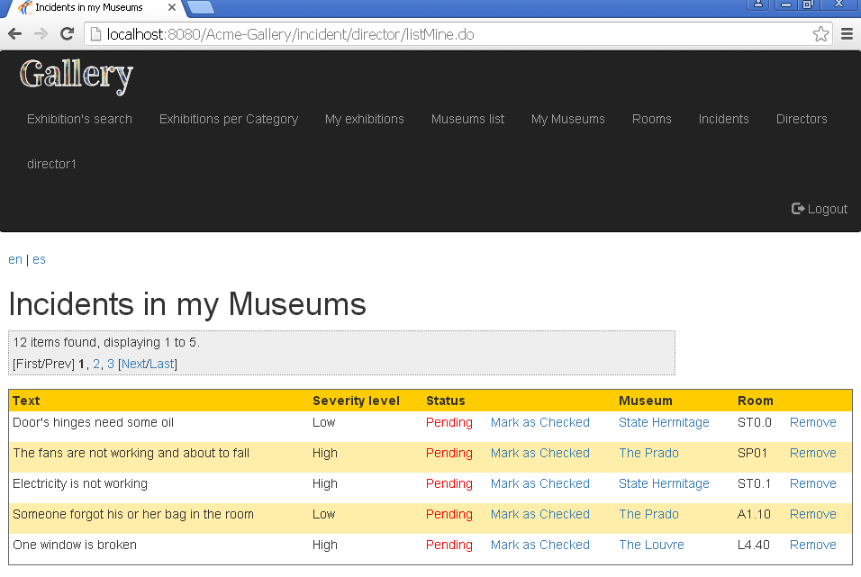Screenshot of the expected wrong results:

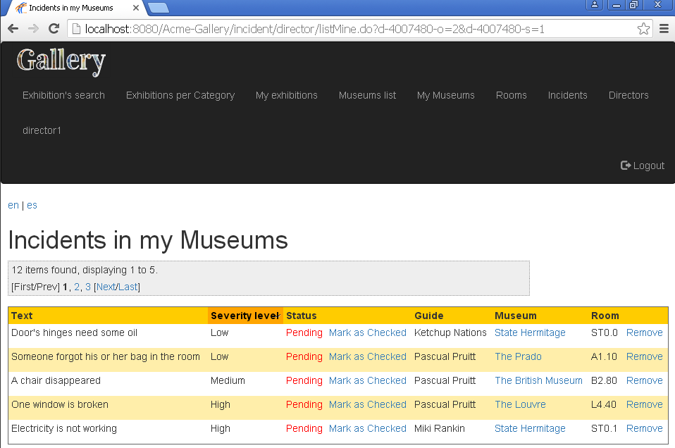Screenshot of the correct results:

Results

We made it explicit on Test #005 from UC024 to try sorting for the severity level column.

The testers reported on this error and wrote down the column’s name wasn’t right-spelled in the test case and that there was no option to click and sort the column.

# Bug in use case 025 – Director delete an Incident

Description

We removed a column from the Incidents’ listings: the guide that reported it but, included that column in the acceptance tests as mandatory information to be shown.

Screenshot of the expected wrong results:

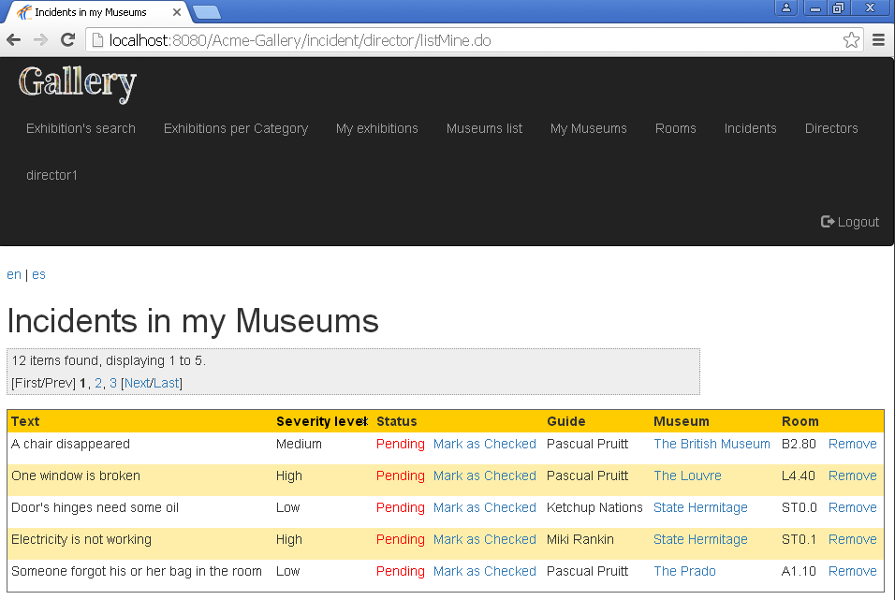Screenshot of the correct results:

Results

We made it explicit on Test #001 from UC025 that the listings must show text, severity level, status, “Mark as checked”, guide, museum, room and “Remove”.

The testers reported on this error and wrote down that the guide’s column didn’t appear.

# Bug in use case 026 – Director create a Museum

Description

We removed a column from the Museums’ listings: the price but, included that column in the acceptance tests as mandatory information to be shown.

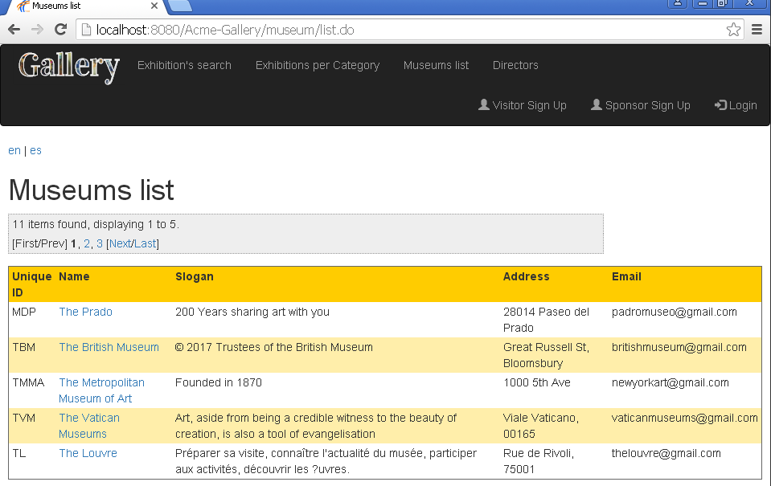Screenshot of the expected wrong results:

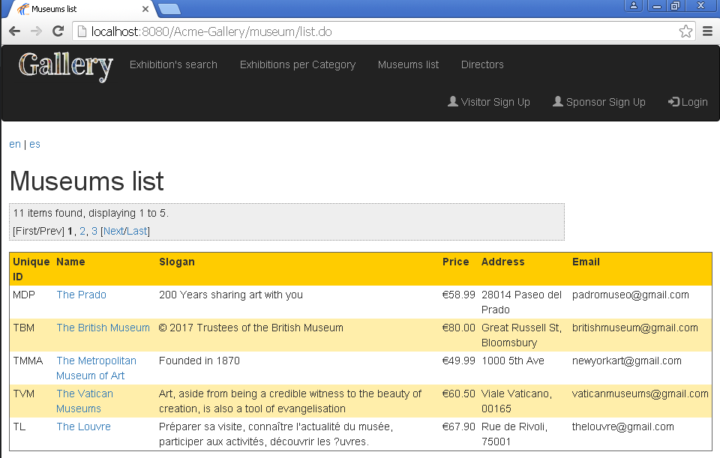Screenshot of the correct results:

Results

We made it explicit on Test #001 from UC026 that the listings must show unique ID, name, slogan, price, address, and email.

The testersdidn’t report on this error and wrote down that they didn’t know the credentials to log in as a Director.

# Bug in use case 030 – Director create a Room

Description

We removed the sortable attribute from the name columns in the Rooms’ listings but, included that functionality in the acceptance tests as mandatory.

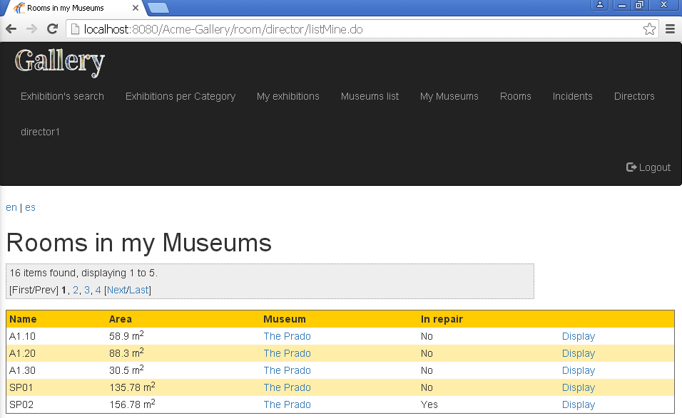Screenshot of the expected wrong results:

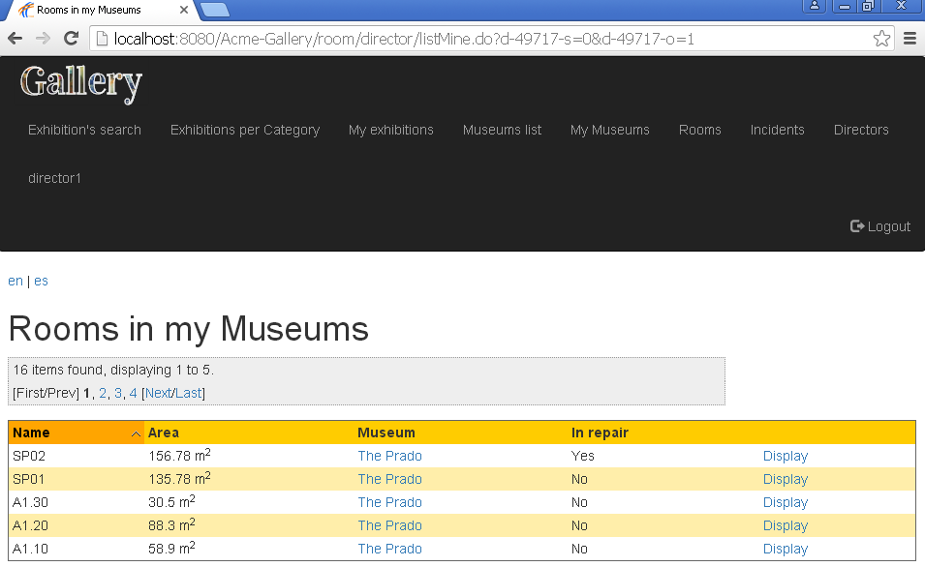Screenshot of the correct results:

Results

We made it explicit on Test #009 from UC030 to try sorting for the name column.

The testers reported on this error and wrote down that the column was static and couldn’t be sorted.

# Bug in use case 032 – Director mark a Room in repair

Description

In the display view of a Room, there’s a link to display the museum where it belongs. We broke the link (“museum/director/display.do?museumId=****”) by changing the value of museumId to a random String.

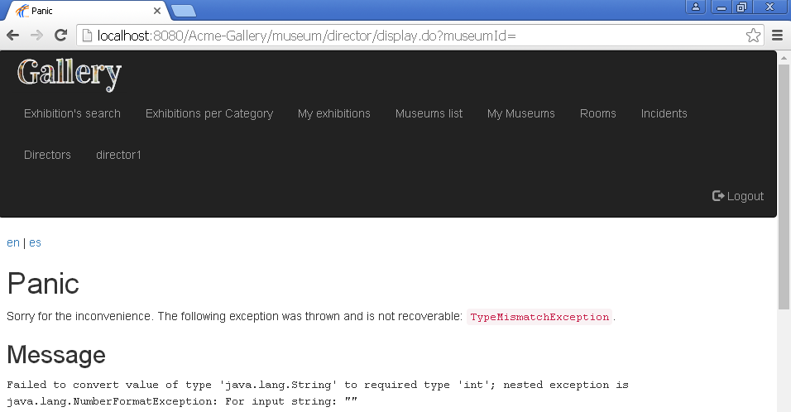Screenshot of the expected wrong results:

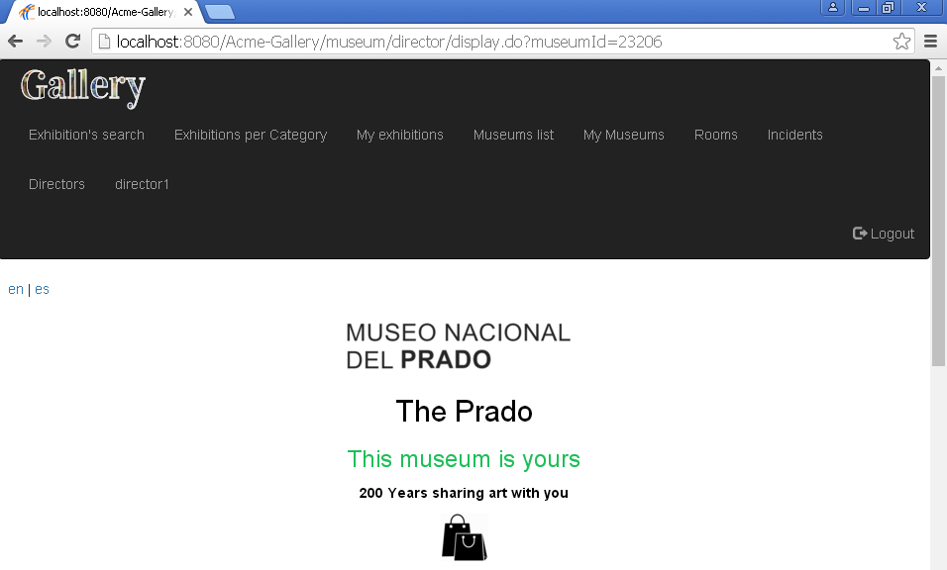Screenshot of the correct results:

Results

We made it explicit on Test #006 from UC032 to check the museum’s link.

The testers reported on this error and wrote down that the museum’s ID wasn’t sent through the URL.

# Bug in use case 042 – Visitor create a Comment

Description

We left some hidden information in the HTML from the view to create a Comment: its containsTaboo, childrenComments, parentComment, visitor and group properties.

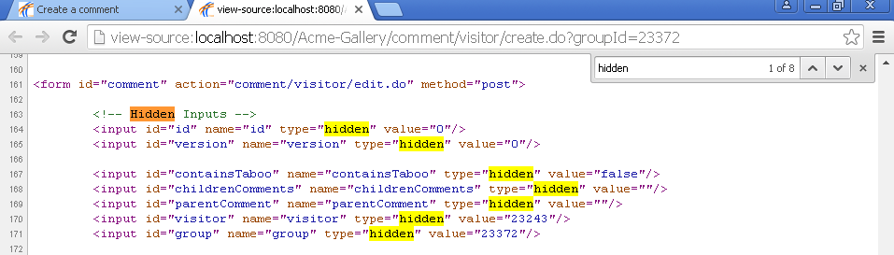Screenshot of the expected wrong results:

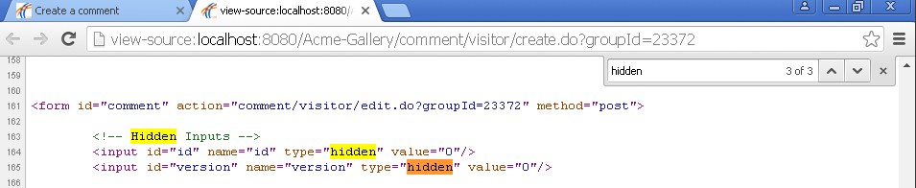Screenshot of the correct results:

Results

We made it explicit on Test #007 from UC042 to search in the HTML for any hidden information.

The testers reported on this error and included a screenshot of all the seven hidden inputs in the HTML.

# Bug in use case 043 – Visitor buy a day pass for an exhibition

Description

We changed the requestURI attribute from the table of artworks, so that no-one can access to the pagination links because the URLs don’t follow a valid pattern (it’s written “exh1bition” instead of “exhibition”).

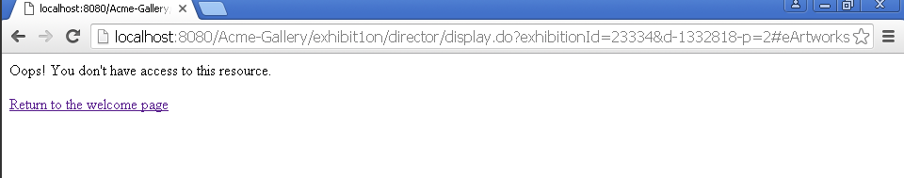Screenshot of the expected wrong results:

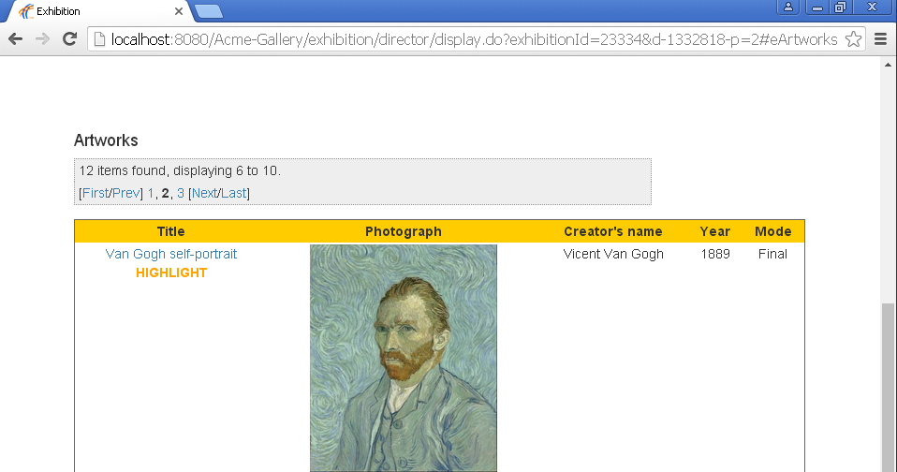Screenshot of the correct results:

Results

We made it explicit on Test #006 from UC043 to check every pagination link.

The testers reported on this error and included a screenshot of the error view.